1. **INTRODUCTION**
   1. *overview*
      * *Description of the project*

Project Description:

HealthHub Medical Clinic, a healthcare facility, relies on Zoho Books to manage patient billing and invoicing. They can track medical service fees, manage insurance payments, and generate statements for patients. Zoho Books helps them maintain financial transparency and ensures efficient billing processes.

* 1. **PURPOSE**

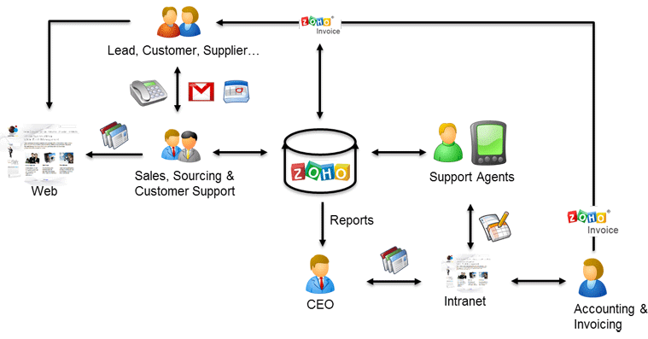

As a Center of Excellence, HealthHub Clinics offers multi-disciplinary resources and smart healthcare solutions, supported by a holistic and compassionate approach, understanding and quality care designed around your health.

1. **Problem definition & design Thinking**
   1. *Empathy map*

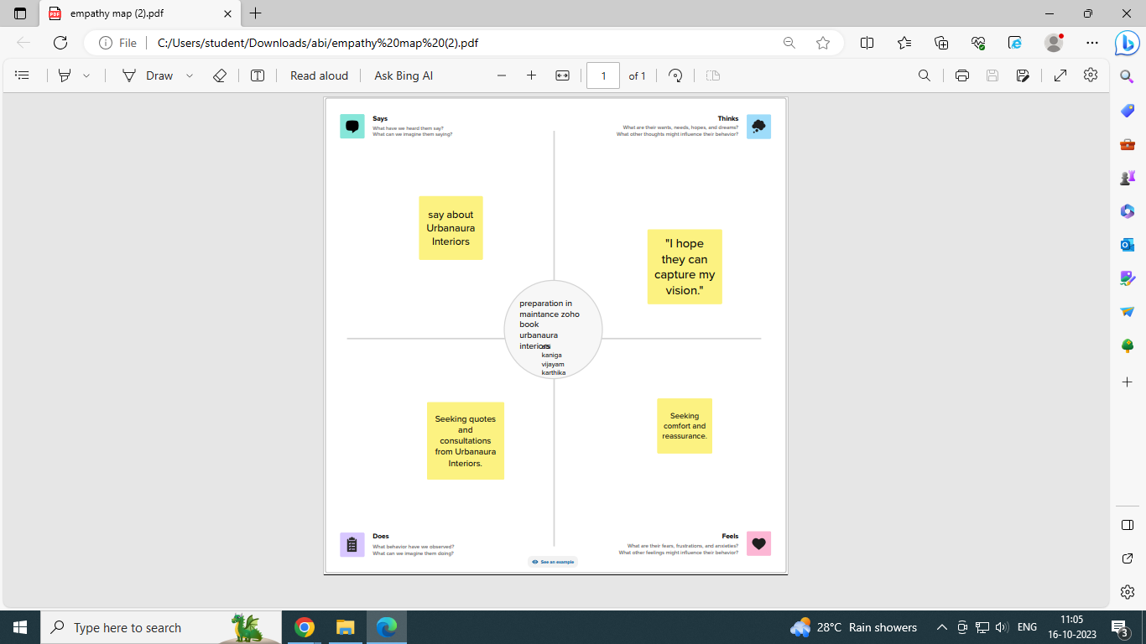

* 1. *Ideation & Brainstorming map*

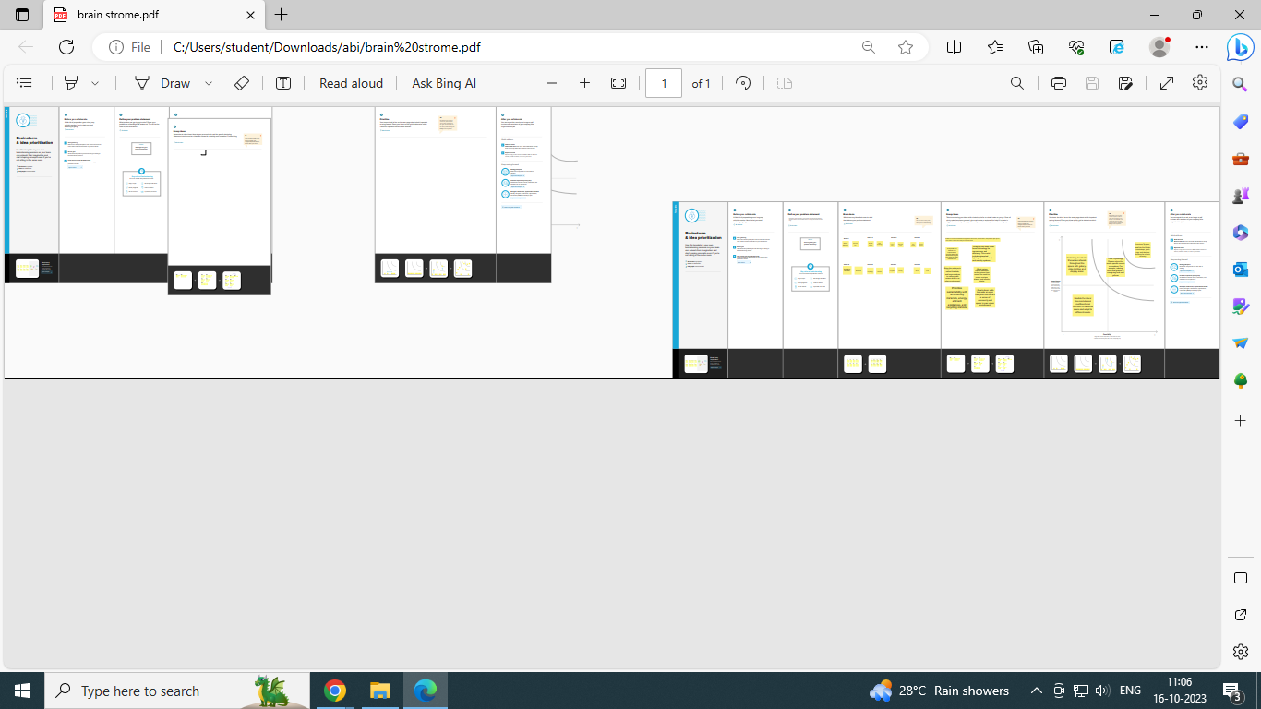

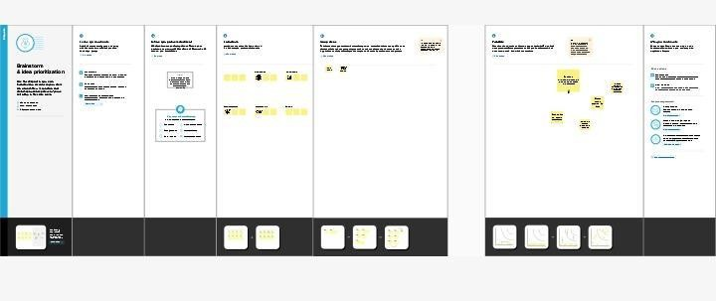

1. **Result Profit&loss**

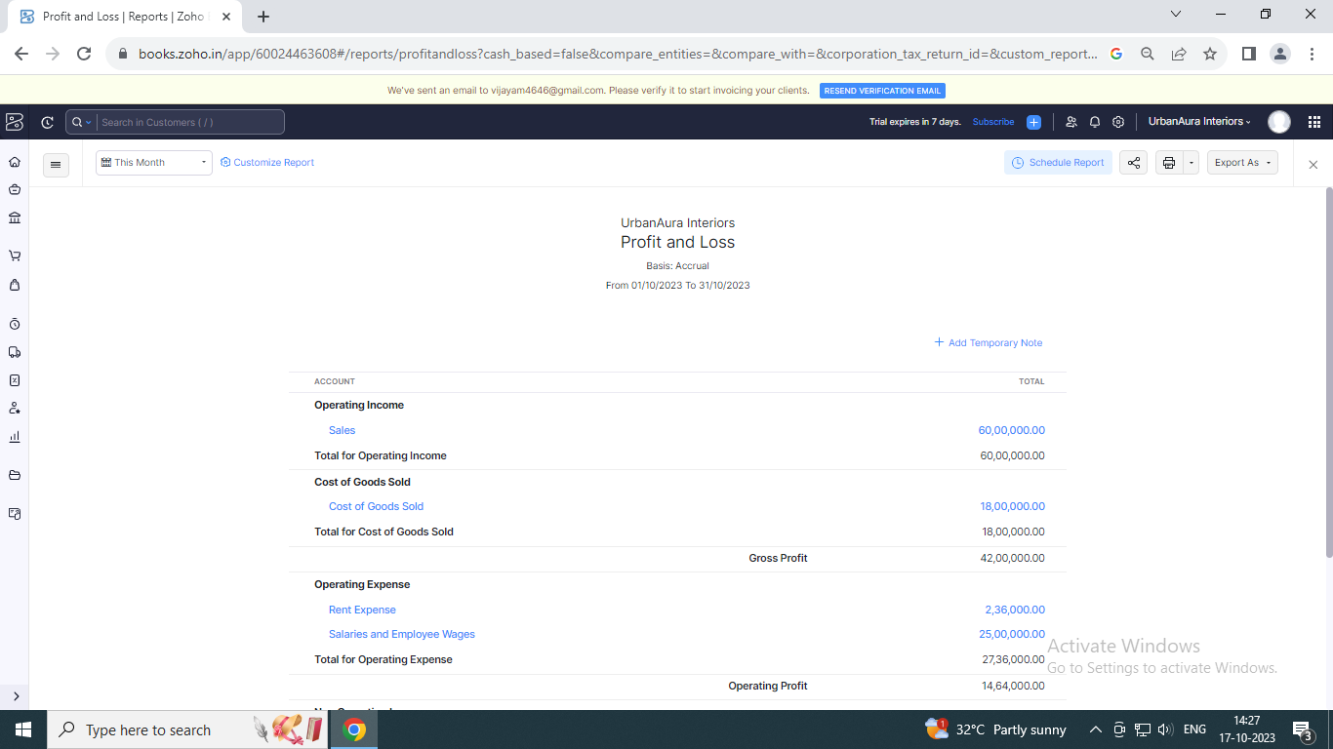

Balance sheet:

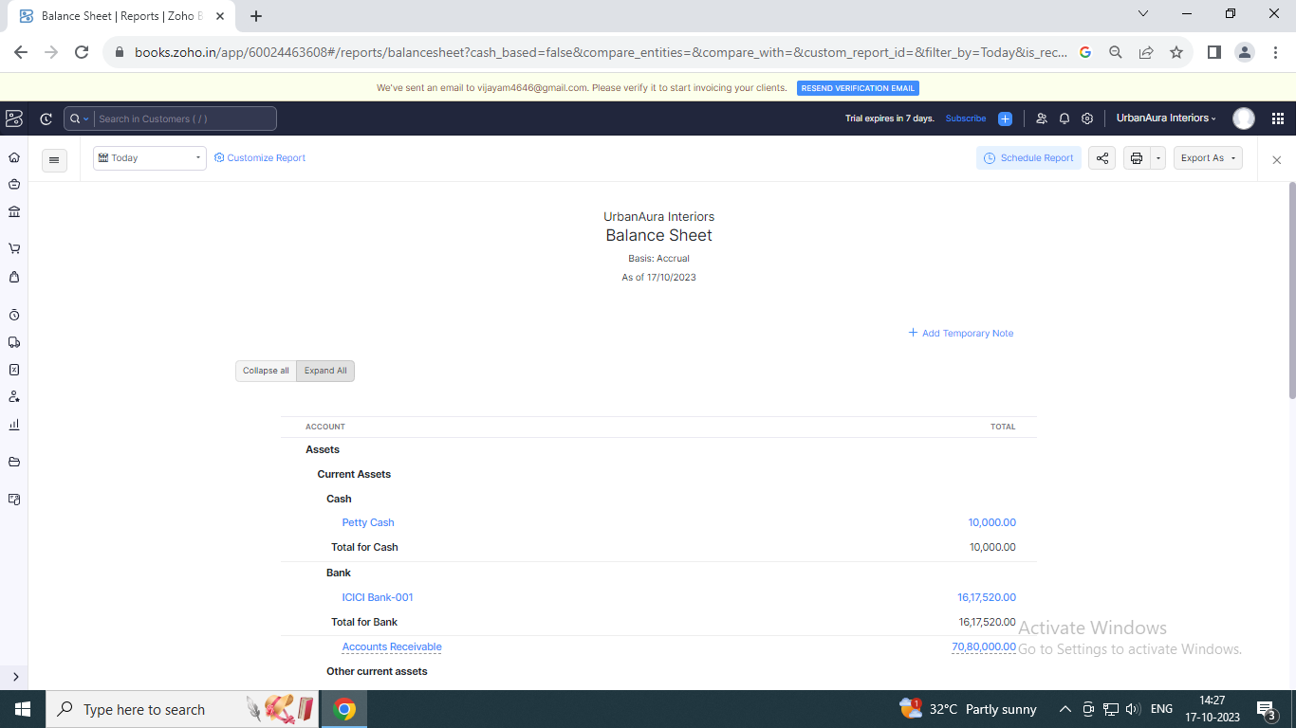

Purchase order:

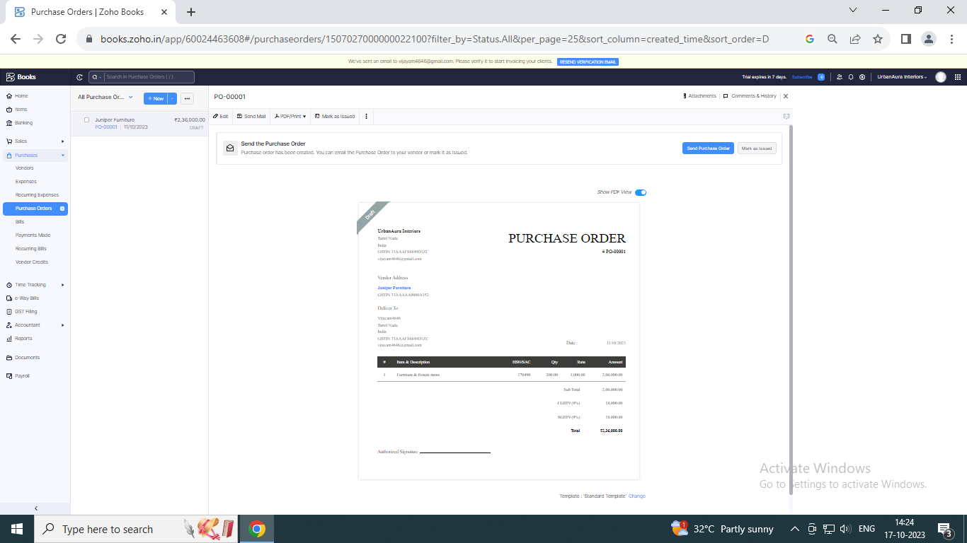

ADVANTAGES OF URBAN AURA INTERIORS ;

These features include automatic climate control, tyre pressure monitoring system, 6 airbags, cruise control, automatic headlights and rear AC vents. The mid S and SX variants of the Aura sedan offer a long list of features, delivering good value for money.

DISADVANTAGE OF URBAN AURA INTERIORS :

Low mileage as shown in the catalog Only 11-12km per ltr in the city and 14-15 km on the highway

A aspared to quoted mileage of 20.5 kmpl Less pickup on AMT mode, lacks especially

while moving upwards on a flyover, For looks, Style, and features I will give 5 out of 5 star But for mileage, I will give ...

APPLICATIONS:

URBAN AURA INTERIORS

CONCULSION:

The Zoho Books are useful to maintain record summarise and analysis accountingentrise made In this cloud based software

We can prepare the bill and maintain accounts in one software

We need any manual records to maintain the accounts

FUTURE SCOPE:

Zoho books now supports recurring payments through strip

You can now receive recurring payment from your customer within payments cards issued in India by Eighter or master card

However your customer card details will be saved only if they choose to save their cards while making cards

APPENDIX: